# 

Simple AI Project Manual

# Purpose

This document provides a step-by-step instruction on how to create an AI project in ALEX and use the resulting model in a prediction flow.

# Steps

1. Sign in to the ALEX GUI with the provided credentials and the URL
2. At the home page click to the ‘New Project’ button

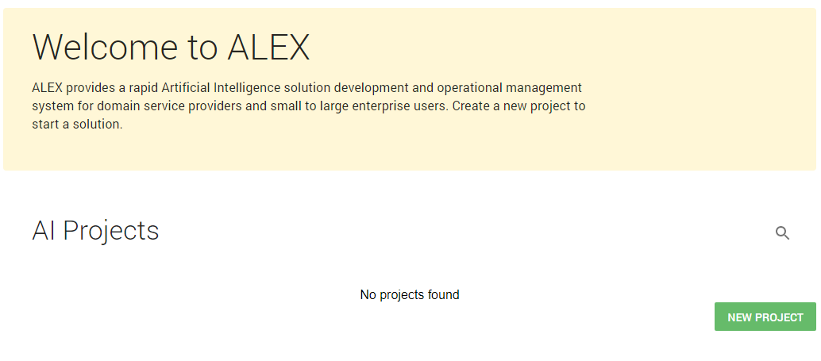

1. Enter the project name and choose ‘CSV’ as the project type. Upload the file with a file picker or with drag-n-drop.

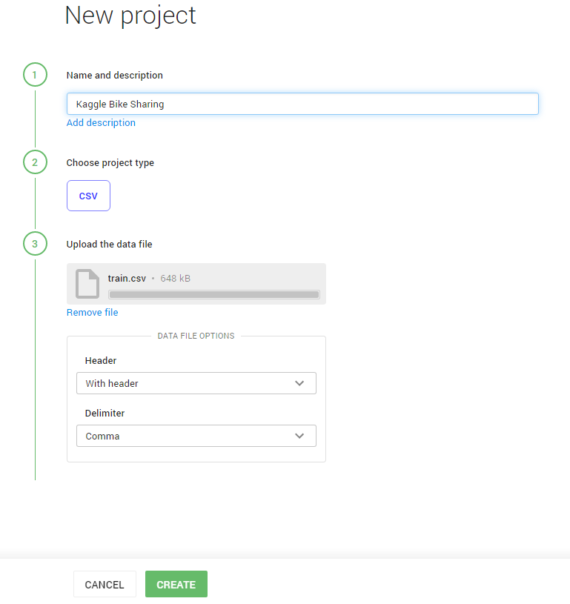

1. At the next step the GUI parses the provided features meta info from file and displays it; it is possible to change features’ settings if required (i.e. set a type to categorical).

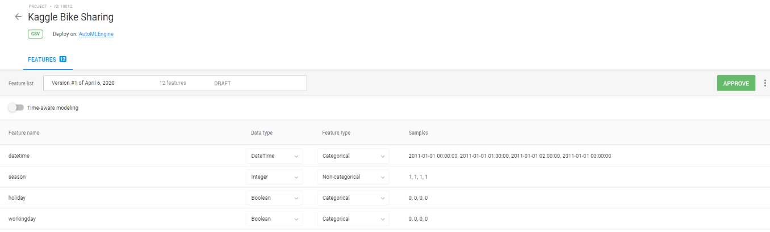

1. The ‘Approve’ button allows to finish the data configuration and allows to proceed with the modeling configuration. Go to the ‘Models’ tab of a Project and push the ‘Create Model’ button. Note: the tab and the modeling step may become active in a while after the project was approved because the system needs time to digest the data first.
2. Once the ‘Create Model’ button becomes available, the first step is the target value and an ML metric definition. Choose the model type (Regression or Classification), metric and other parameters according to the business case.

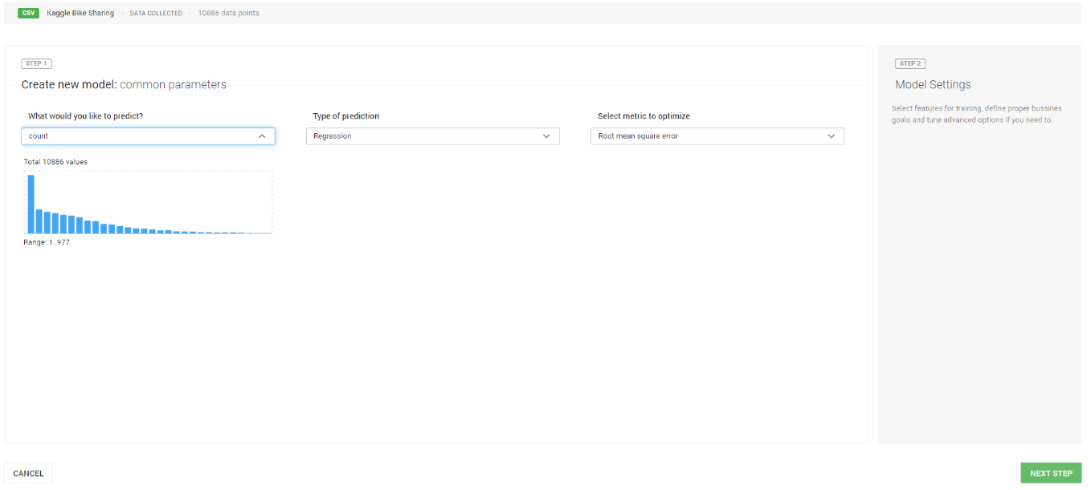

1. Once the first step configuration was finished, proceed with the second step – choose a subset of features (if applicable), also it is possible to tweak some advanced parameters (the default values are totally fine though).

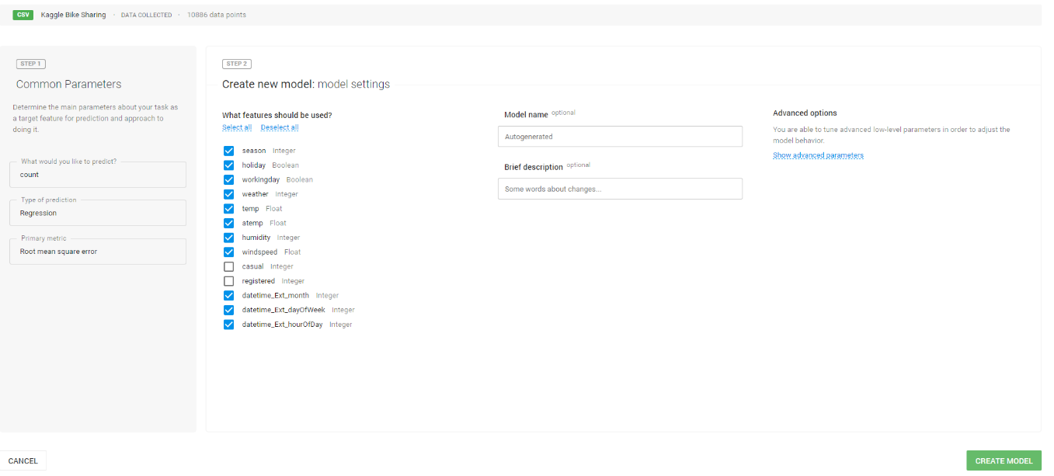

1. Pressing the ‘Create Model’ button leads to pushing the model to ALEX for training and execution and opens the model’s page. The Model Page allows tracking the progress of the model’s training process.

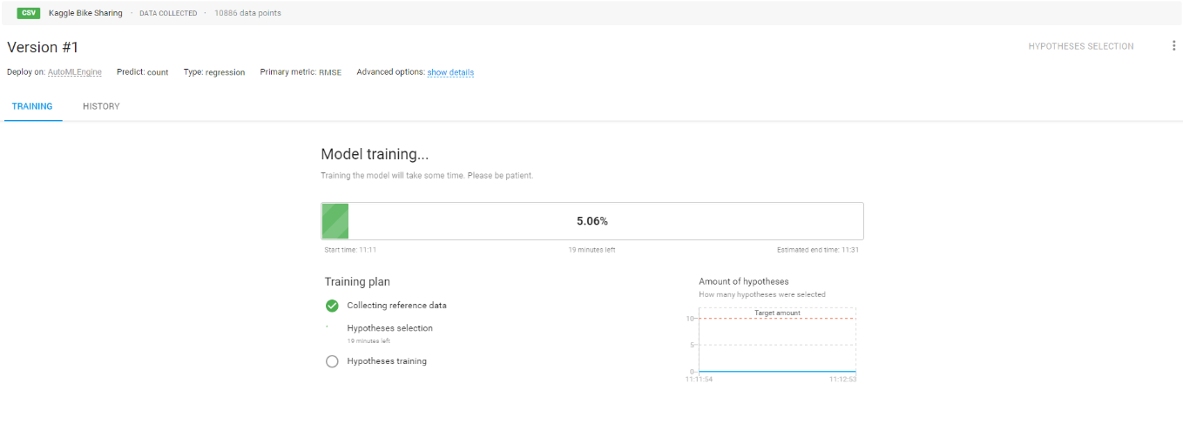

1. Once the model’s training was finished the Model Page displays a lot of information.

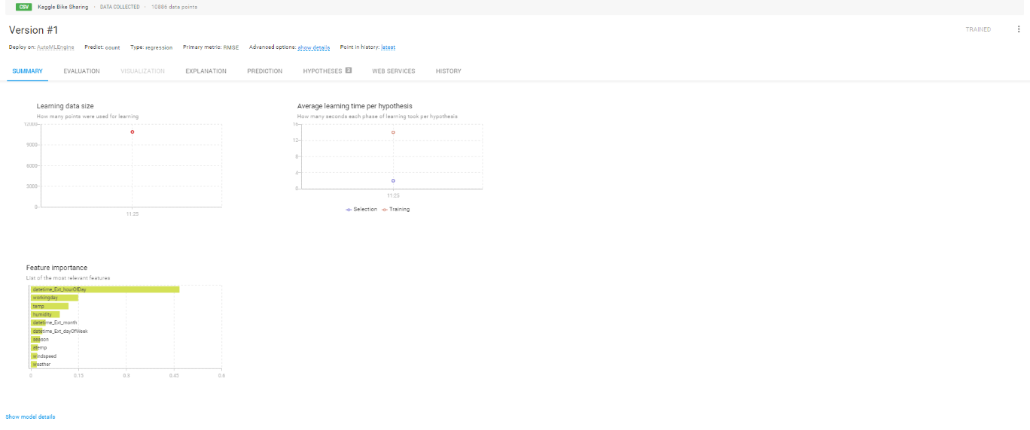

The Summary tab displays the basic information about the model.

The Evaluation tab displays the model’s metrics on Train, Holdout and Test data sets. The whole set of supported metrics per model’s type (Classification, Regression) is calculated to provide the best overview of the model’s performance.

The Hypotheses tab provides details on which algorithms and hyperparameters were selected for modeling.

The History tab displays information about important transitions in the model’s lifecycle.

1. The obvious goal of building a model is the capability to use it for prediction. There are different ways to do it for CSV-based models, they are listed below.

**Batch prediction for CSV-based models**. It is assumed that a user has a CSV file with features where the target value column is missing. The batch prediction can be triggered from a Prediction tab of the Model Page.

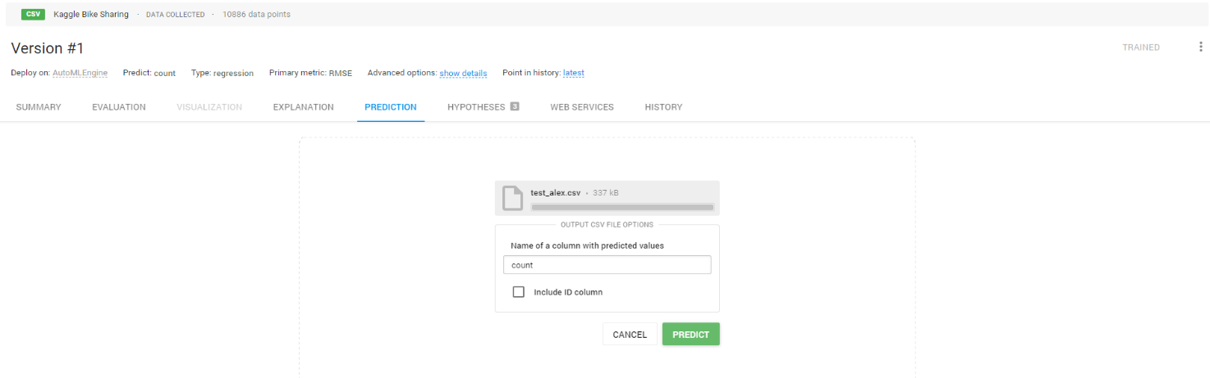

The prediction results in form of CSV can be downloaded when the prediction task is finished.

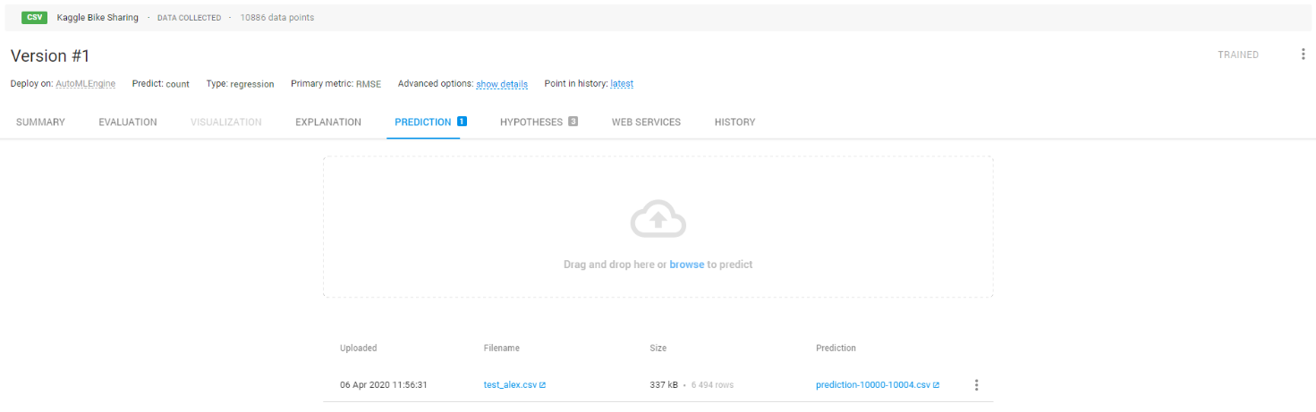

**Per-record prediction via HTTP (REST) for CSV-based models**. It is assumed that a user can provide calculated features in REST. The REST Endpoint can be enabled at the Web Services tab of the Model Page.

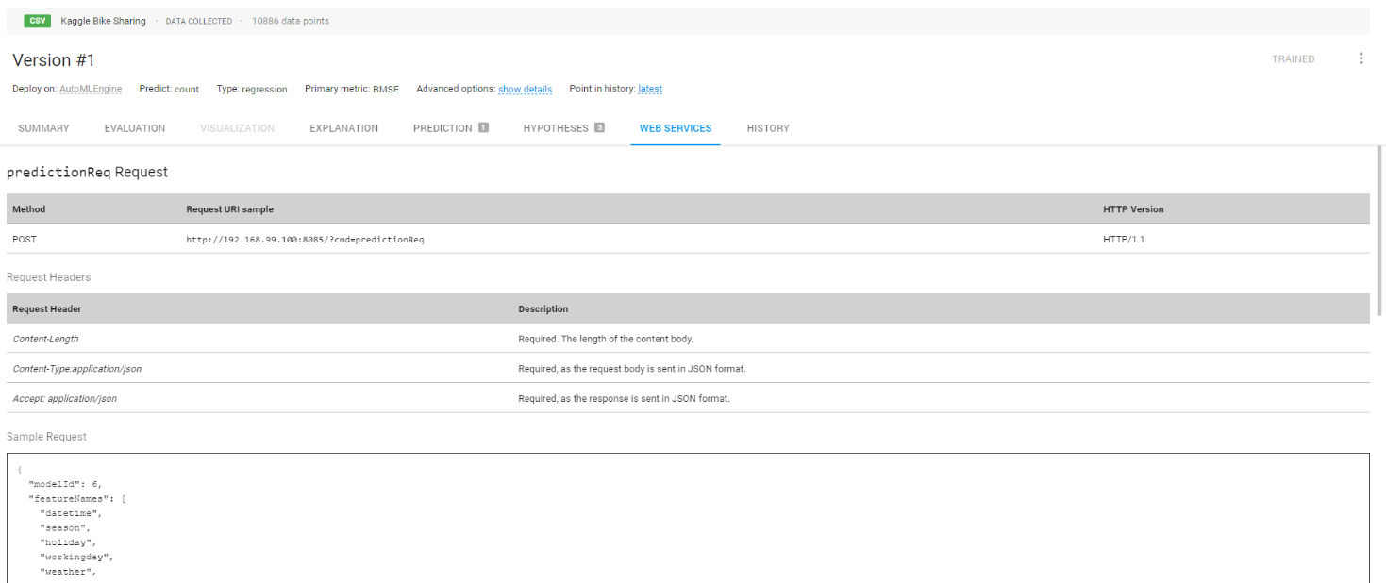

1. The Explanation tab allows to obtain certain insights on the model's decisions. Push the ‘Explain Model’ button, type the number of points to explain and select the ID column.

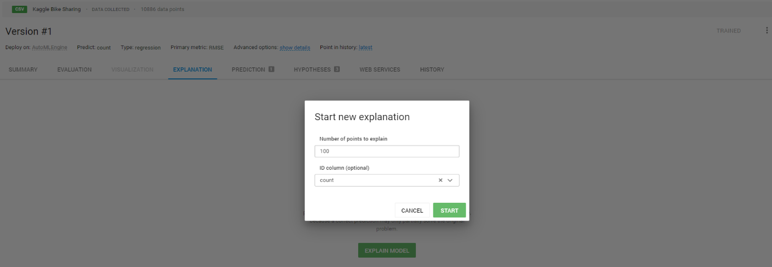

The explanation for each point (from the selected number of points to explain) becomes available when Explanation task is finished.

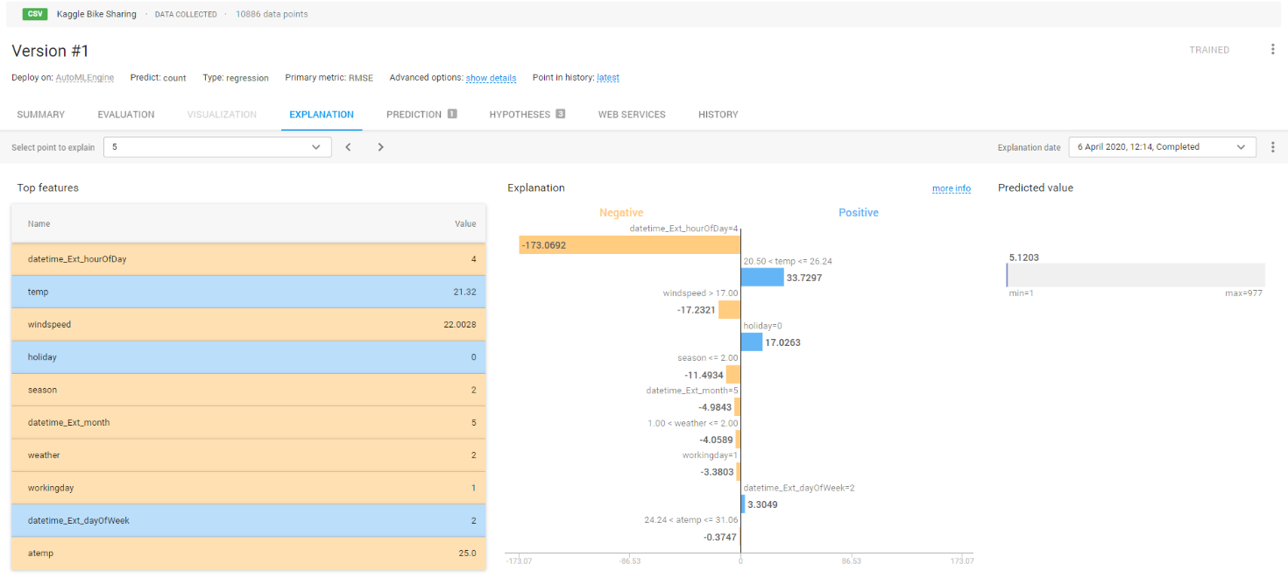

1. Multiple models can be added for the same CSV project, enabling a capability to compare them (they may differ in the feature set, metric, algorithm settings etc).

